Supply List 2024-2025
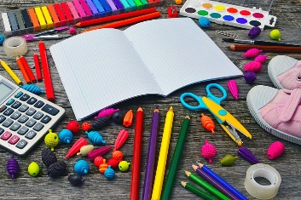

- over the ear headphones
- 2 boxes of Crayola crayons
- 5 pencils
- 3-ring binder (white) 1 ½ inch
- composition book (wide rule; black & white cover)
- 1 vinyl/plastic folder with pockets
- glue sticks
- Crayola colored pencils
- Crayola markers
- scissors
- paper towels
- Lysol wipes
- facial tissue
- labeled screw top reusable water bottle
- labeled bag with extra set of clothes
- pack of baby wipes
- backpack
- plastic pencil box to hold supplies

Note: As previous mentioned in my welcome letter, students will be given a backpack with a limited variety of school supplies. The above forementioned supplies are a suggested need and very much appreciated if you can supply these for your child. If you have already purchased school supplies, bring what you have.

